VASTRAA PROJECT REPORT

Institution: MARIAN COLLEGE KUTTIKANAM

Program: Summer Internship with ICT Academy

Group Members:

* Nikhitha Mary Antony
* Jyothika Jayesh
* Denna Treesa Thomas
* Elizabath Thomas
* Soosanna Subodh

*Executive Summary:*

Vastraa is a fully-functional online fashion store developed to serve as a platform where users can browse, shop, and manage their fashion needs. Built using the MERN (MongoDB, Express.js, React.js, Node.js) stack, Vastraa combines a smooth user interface with powerful backend operations to deliver a scalable and responsive shopping experience. Users can register, explore various clothing categories, add items to cart, and complete purchases via PayPal.

*Introduction:*

In today’s digital era, online shopping has become an essential part of daily life, especially in the fashion industry. To meet the growing demand for a user-friendly and feature-rich shopping experience, we developed Vastraa—a modern fashion e-commerce platform inspired by popular websites like Myntra.

Vastraa offers a seamless interface for users to explore, select, and purchase clothing items across different categories such as Men, Women, Topwear, and Bottomwear. The website ensures a smooth and secure shopping journey, from product browsing to checkout, using technologies like React.js for the frontend, Express.js and Node.js for the backend, and MongoDB for data management. Integration with PayPal allows for secure online payments, while Nodemailer handles email notifications.

This report outlines the design, development, and features of Vastraa, highlighting the key modules, technologies used, and overall functionality of the system.

*Objectives*

The main goal of Vastraa is to deliver a seamless, secure, and efficient online shopping experience. The following objectives highlight the core features aimed at enhancing user experience, ensuring security, and simplifying product and user management.

1. Provide a smooth online shopping experience for fashion items.

2. Develop a responsive and scalable e-commerce platform using modern web technologies.

3. Enable secure user login and registration accessible globally.

4. Allow product uploads and management by admins.

5. Integrate secure payments through PayPal.

6. Offer admin controls to manage users and monitor activities.

*Scope And Deliverables:*

Scope of Vastraa Website:

1. Fashion E-commerce Platform:

Develop an online store for browsing, purchasing, and managing clothing items.

2. User Registration and Login:

Secure user authentication allowing global access and personalized experiences.

3. Product Management:

Enable admins to upload and manage product listings, including images and descriptions.

4. Payment Integration:

Implement secure payment options, such as PayPal, for a smooth checkout process.

5. Admin Dashboard:

Provide an interface for admins to manage users, monitor activities, and control product listings.

6. Email Notifications:

Integrate email functionality for order confirmations and user account updates.

7. Mobile Compatibility:

Ensure the platform is fully responsive and works seamlessly across all devices.

Deliverables:

1. Fully Functional E-commerce Website:

A live, deployed platform with product listings, user authentication, and payment integration.

2. Admin Panel:

A complete backend dashboard to manage users and products effectively.

3. User Profiles and Dashboards:

Features allowing users to view their purchase history and manage account details.

4. Payment Gateway Integration:

Secure and reliable PayPal integration for processing payments.

5. Email System:

Automated email notifications for successful purchases and user actions.

6. Documentation:

Detailed project documentation including setup, deployment, and user guides.

*Methodology:*

1. Requirement Analysis:

Identified key features and functionalities needed for a fashion e-commerce platform.

2. Technology Selection:

Chose the MERN stack (MongoDB, Express.js, React.js, Node.js) for full-stack development.

3. Frontend Development:

Built a responsive user interface using React.js with routing, navigation, and product views.

4. Backend Development:

Created RESTful APIs using Express.js and Node.js for user and product operations.

5. Database Design:

Structured MongoDB collections to store user data, products, and order details.

6. Payment Integration:

Integrated PayPal for secure transaction processing.

7. Email Functionality:

Used Nodemailer to send user notifications and confirmations.

8. Admin Dashboard:

Developed tools for admin to manage users and products.

9. Testing & Debugging:

Performed thorough testing to fix bugs and ensure smooth functionality.

10. Deployment:

Deployed the website for public access with a stable and responsive interface.

*Project Activities:*

1. Requirement Gathering – Identified features needed for the e-commerce platform.

2. UI/UX Design – Designed user-friendly layouts and navigation.

3. Frontend Development – Built responsive pages using React.js.

4. Backend Development – Created APIs using Node.js and Express.js.

5. Database Setup – Configured MongoDB for storing user and product data.

6. Payment Integration – Added PayPal for secure checkout.

7. Email Notification Setup – Used Nodemailer for sending confirmation emails.

8. Testing & Deployment – Tested the website and deployed it for live use.

*Results And Findings:*

1. A fully working fashion e-commerce website was successfully developed.

2. User login, registration, and profile management function smoothly.

3. Products can be added, viewed, and managed easily.

4. PayPal integration ensures secure and reliable payments.

5. Admin dashboard allows effective user and product control.

6. Email notifications are sent for key user actions.

7. The website is responsive across all devices.

8. Backend and database operations are stable and efficient.

*Conclusion:*

In conclusion, the Vastraa project successfully achieved its goal of creating a user-friendly and secure fashion e-commerce website. With a well-integrated frontend, robust backend, and essential features like product management, user authentication, payment integration, and admin control, the platform delivers a complete online shopping experience. The use of modern technologies ensured scalability, responsiveness, and reliability. This project not only met the defined objectives but also provided valuable insights into full-stack web development and real-world application design.

*Appendix:*

GitHub Repository: <https://github.com/nikhithanikki2004/Vastraa.git>

Our Website Link: <https://vastraa-nikki.vercel.app/>

Demo Video Link: <https://drive.google.com/file/d/1wYub8GZ33a47hGTQaKKyLCvafQOHtO-X/view?usp=sharing>

Demo Photos:

Home page

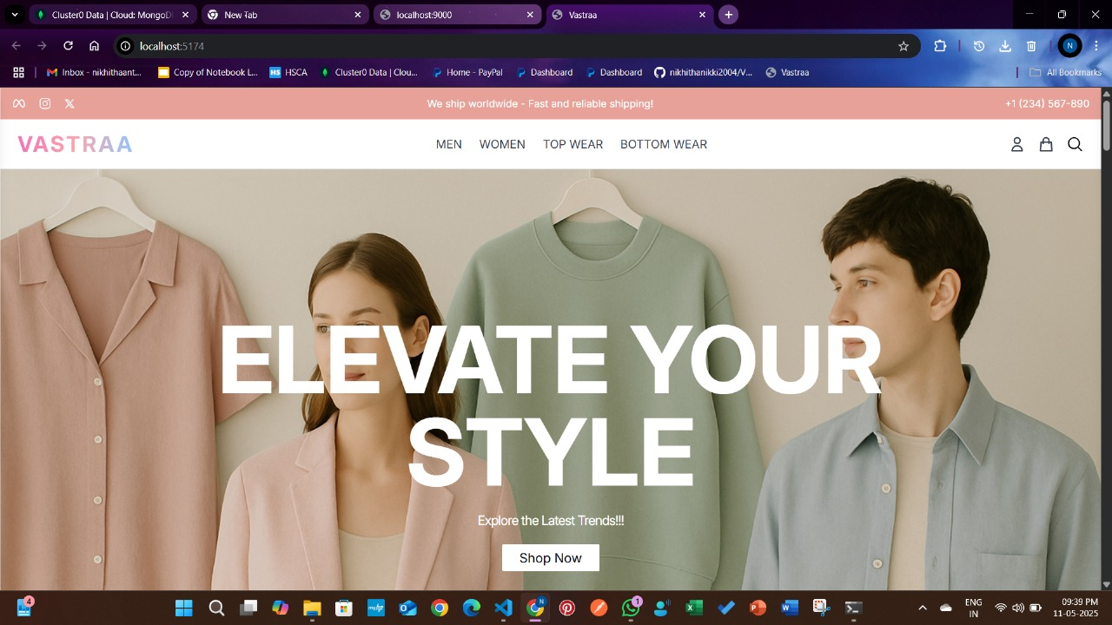

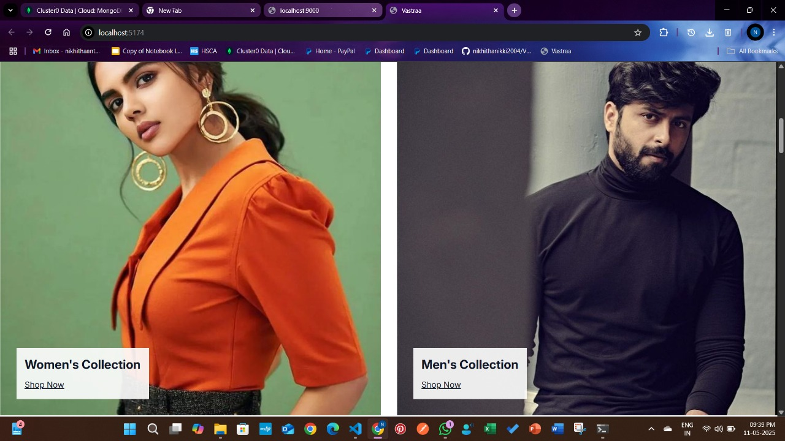

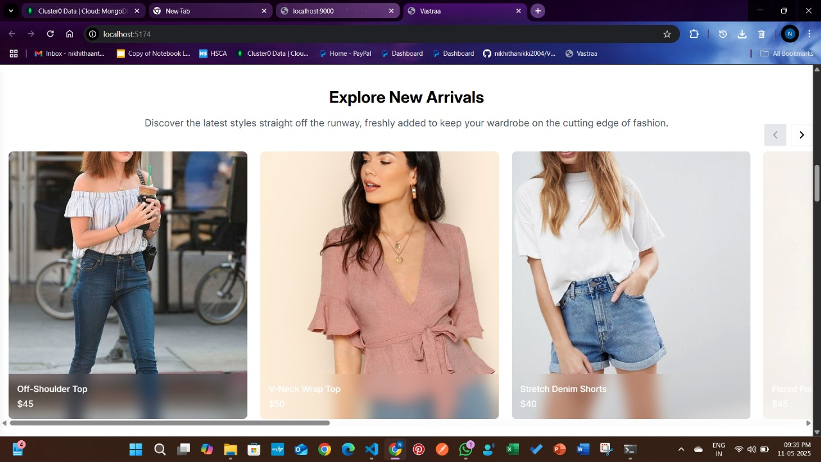

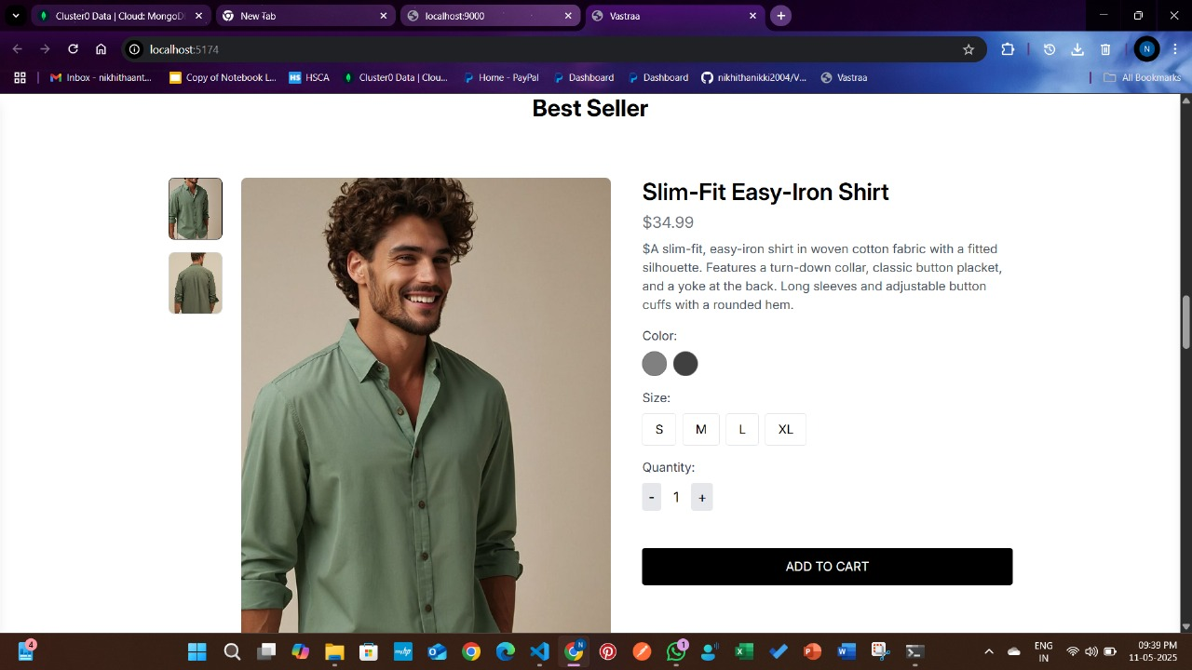

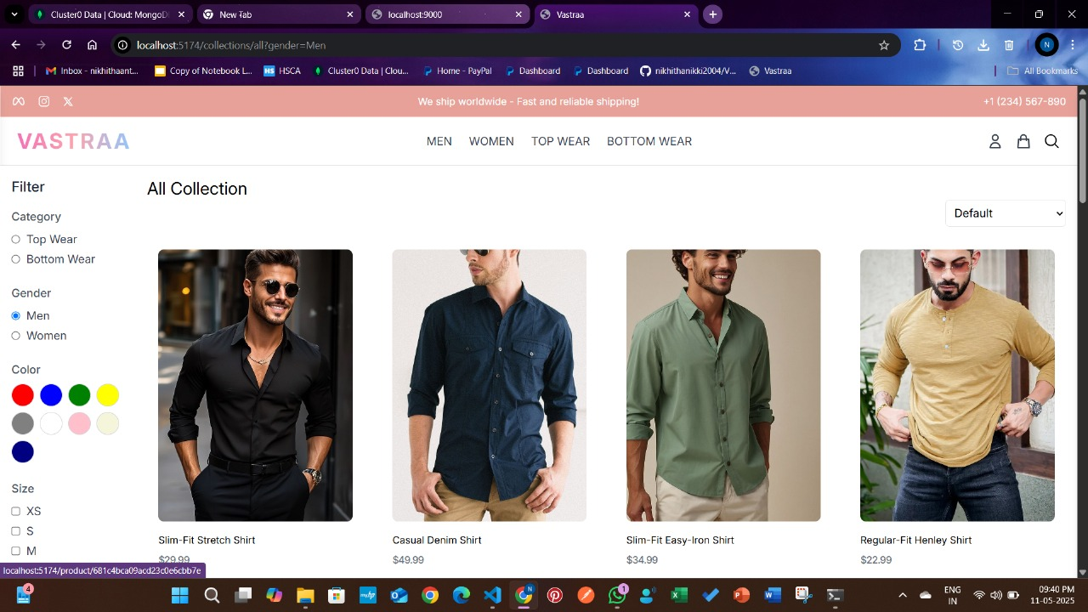

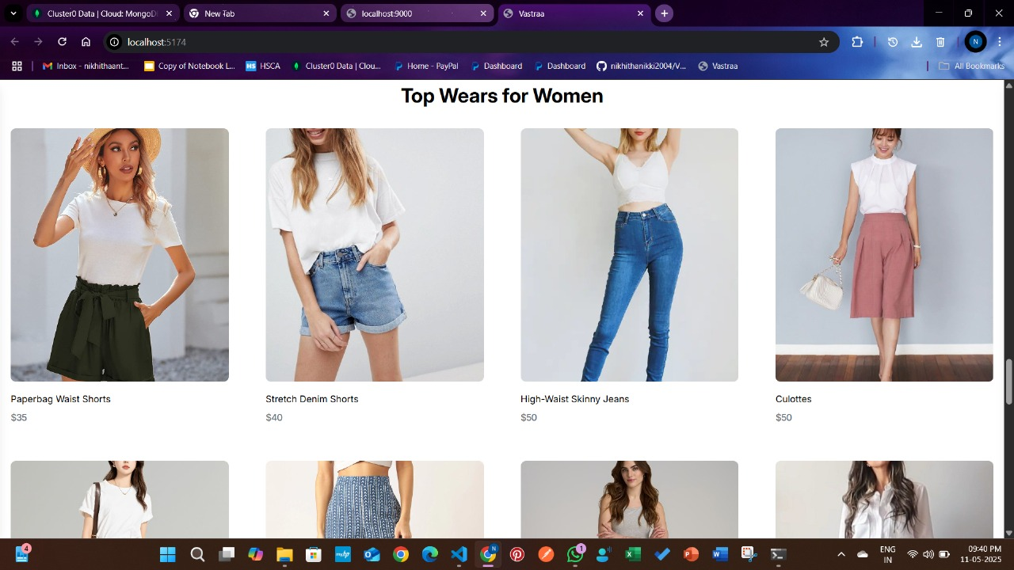

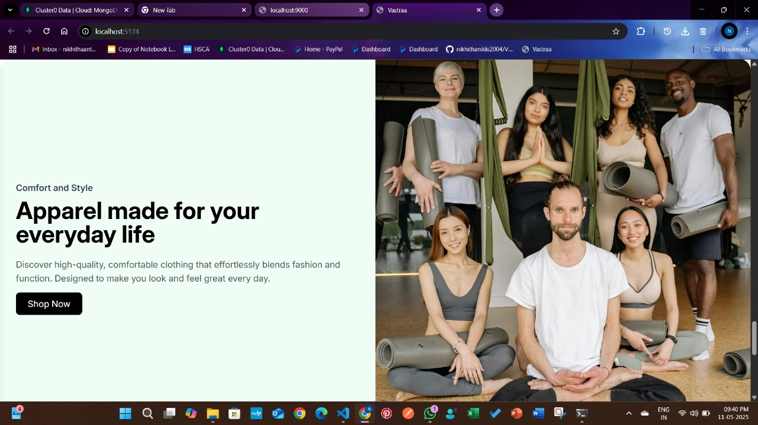

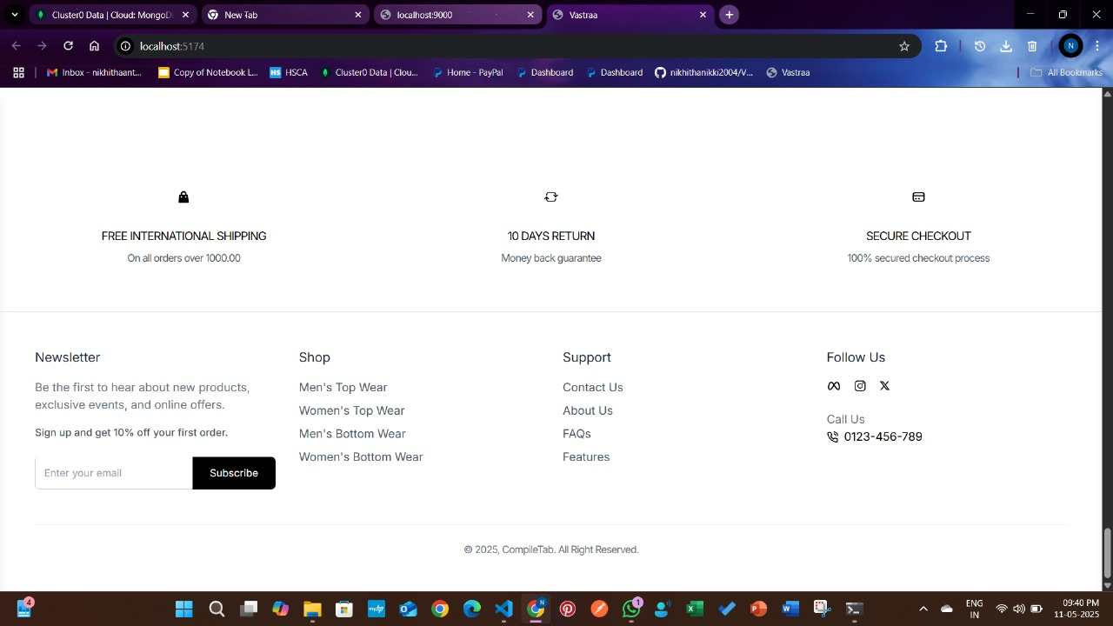

Sign In

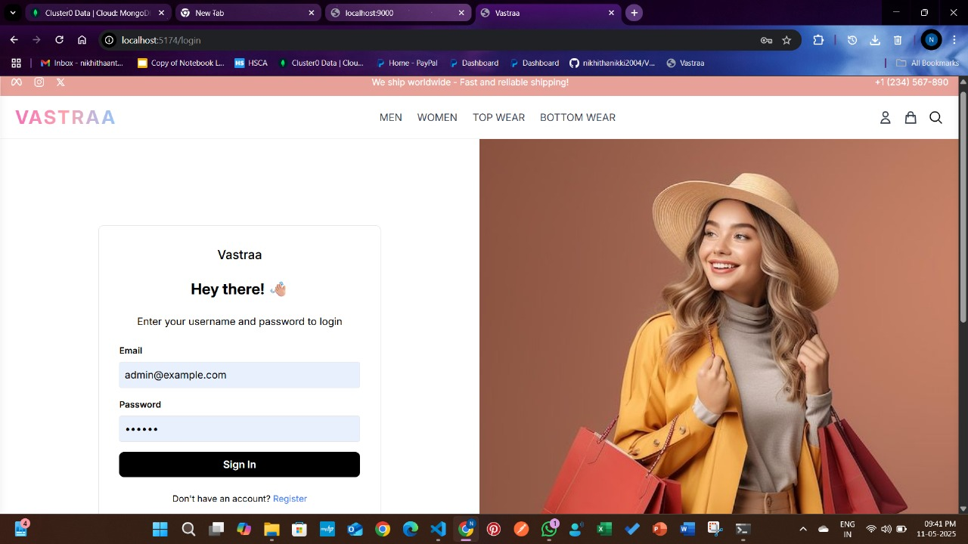

Register

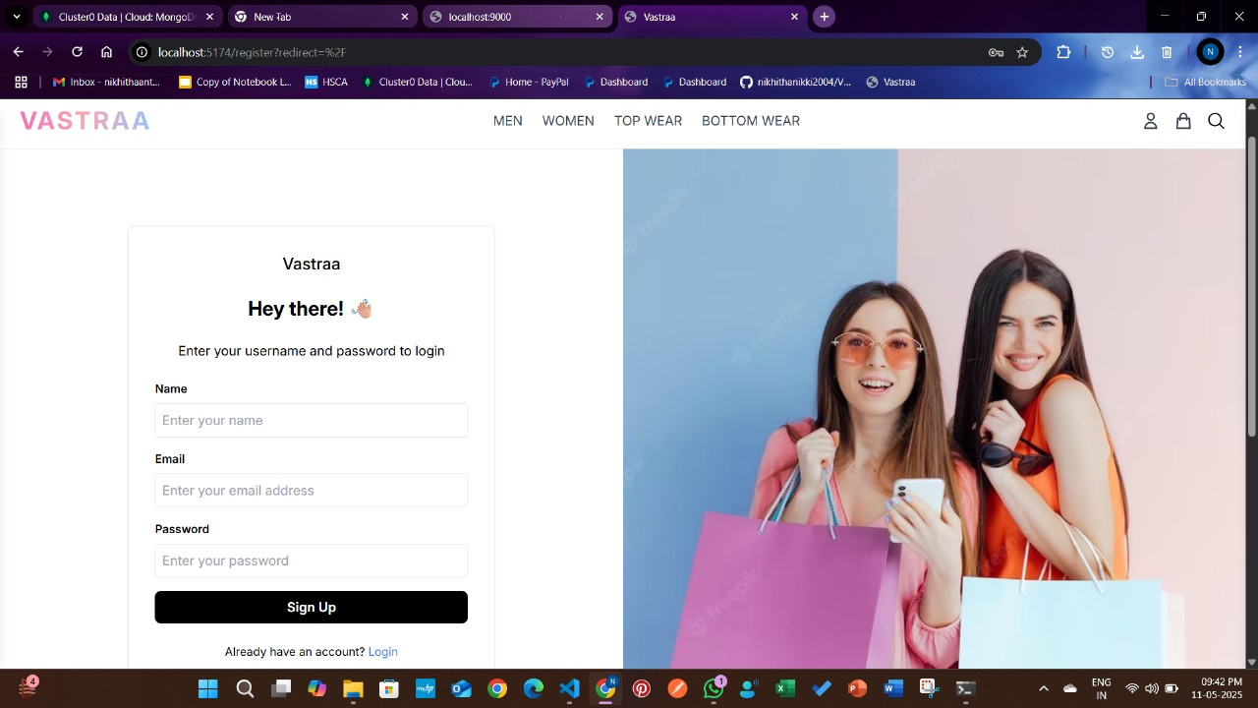

Admin

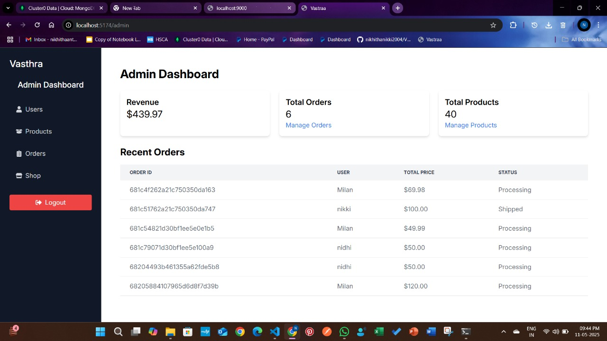

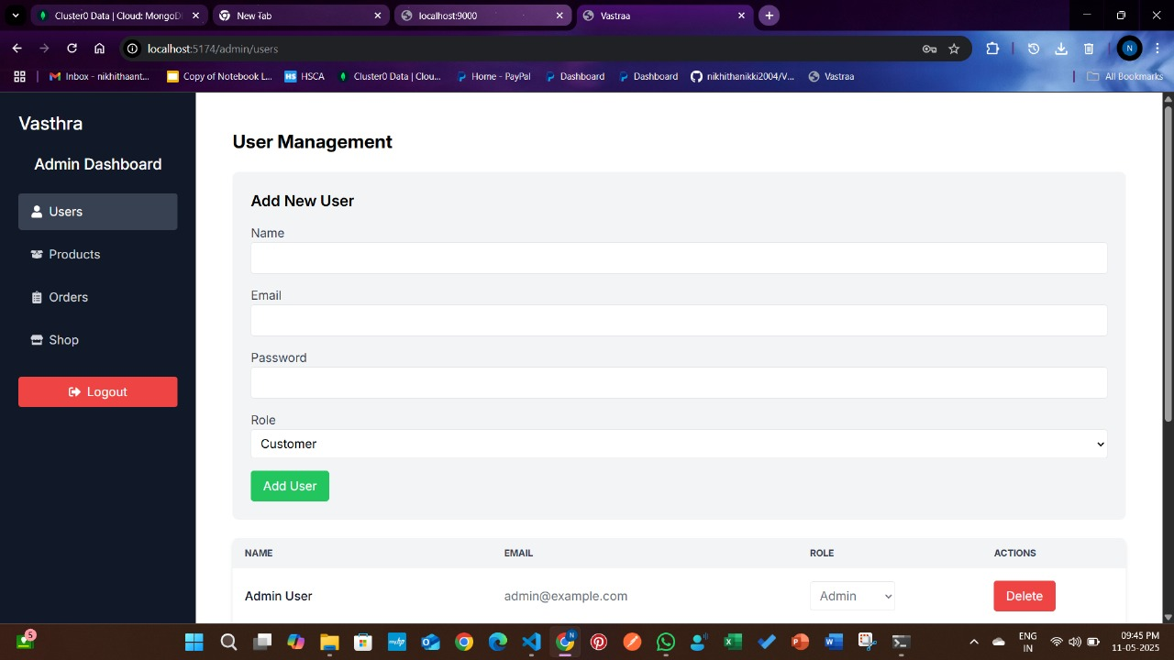

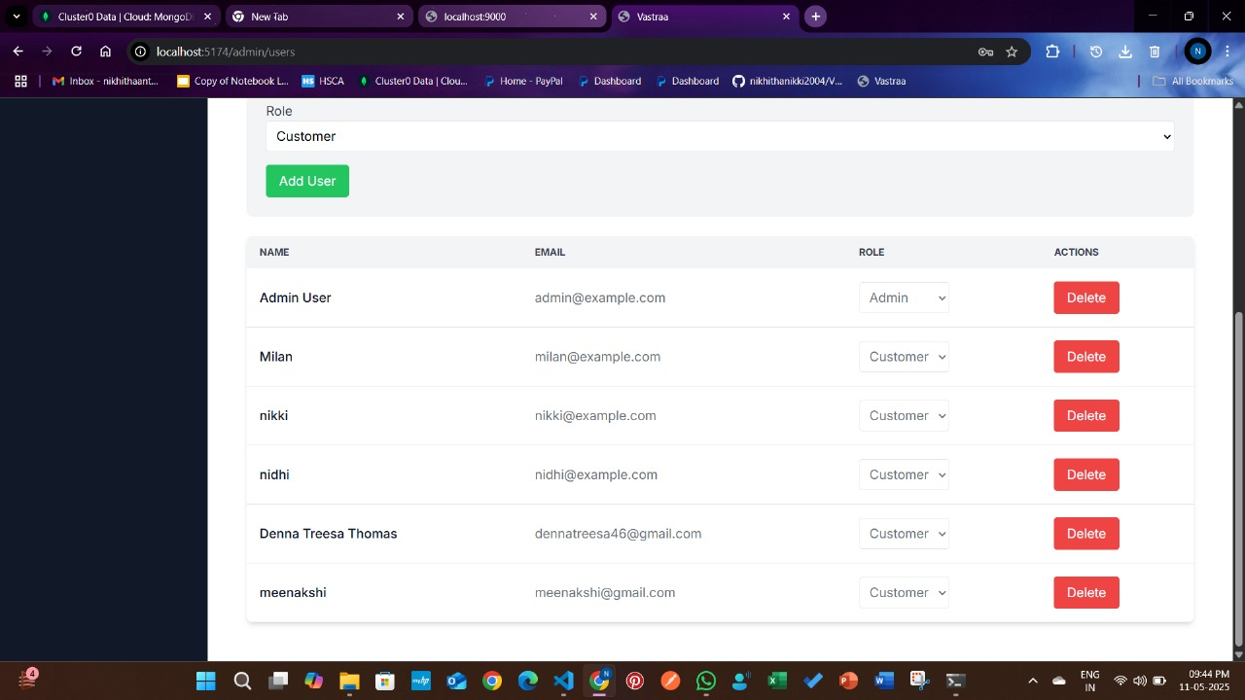

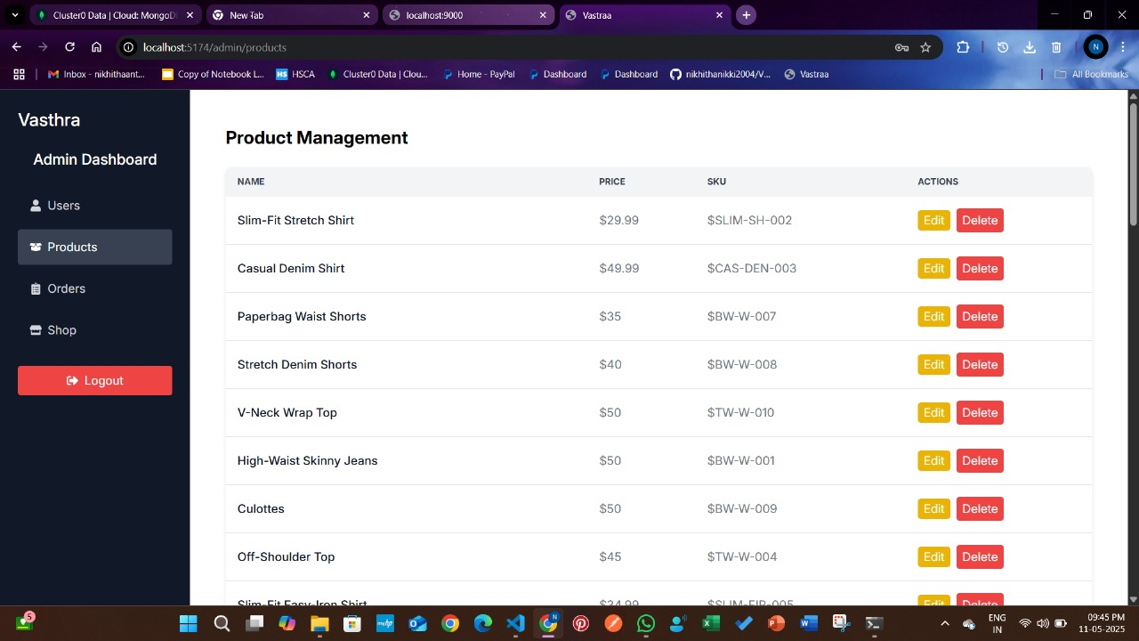

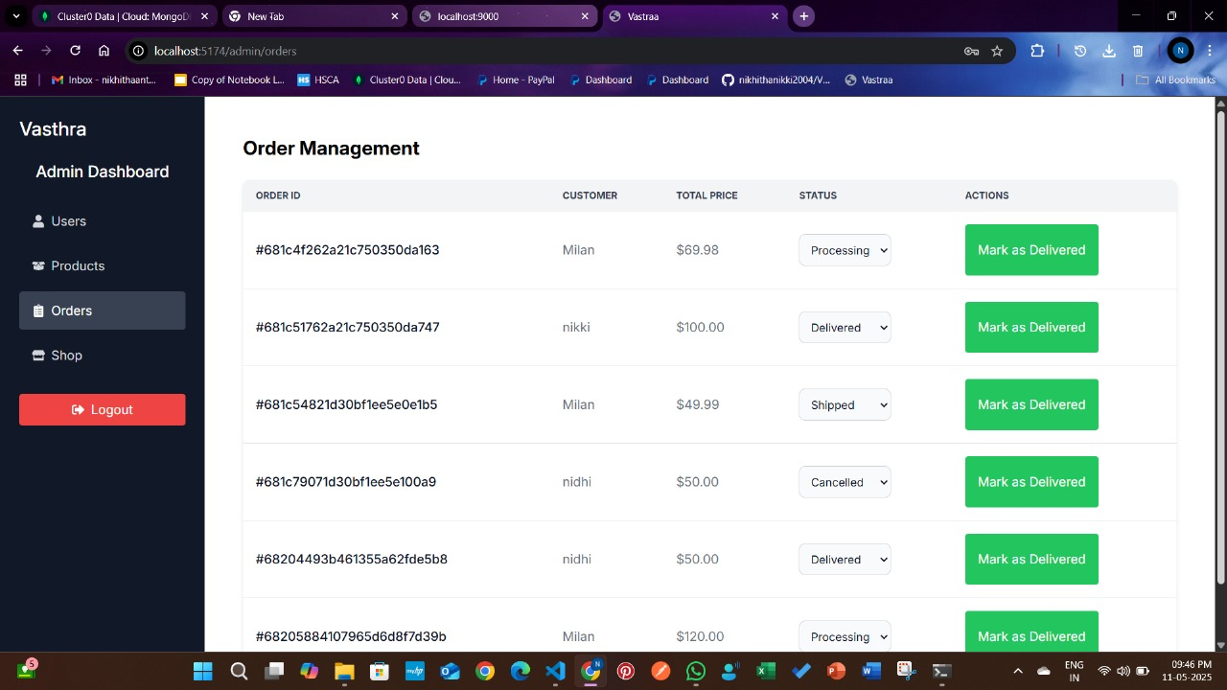

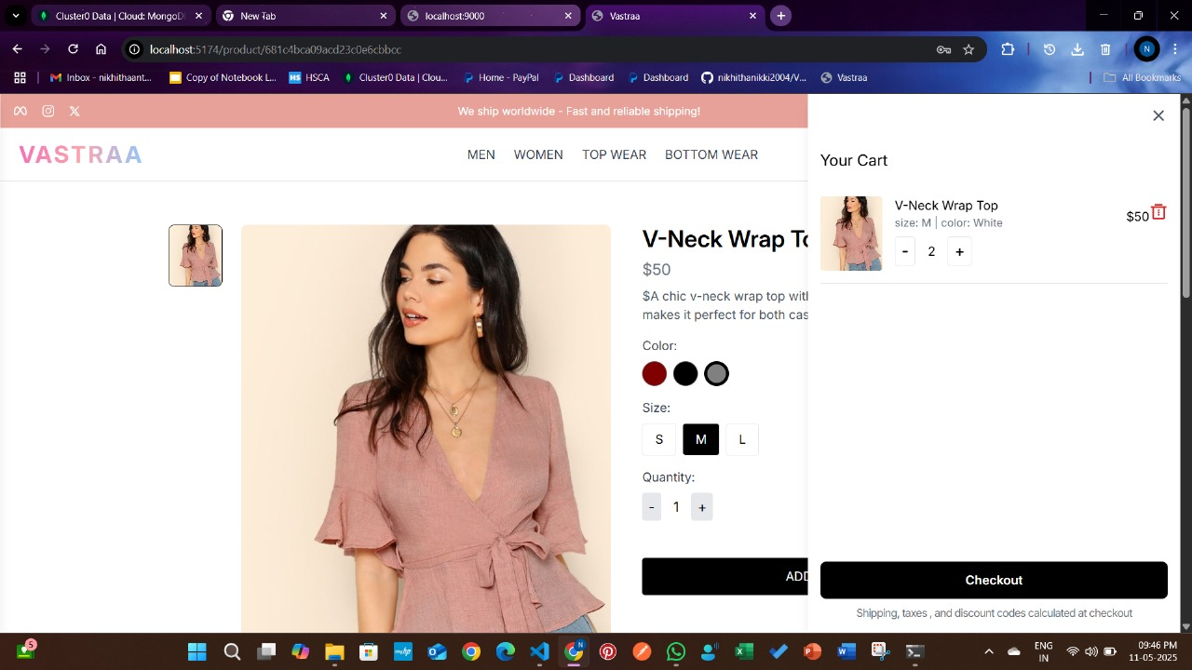

Payment With PayPal

